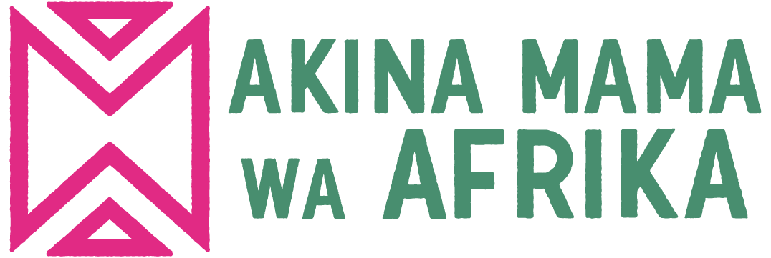

Job Title: Communications Coordinator
Organization: Akina Mama wa Afrika (AMwA)
Duty Station: Kampala or remotely within Africa preferably in countries where AMwA has national programmes (Uganda, Ethiopia, Kenya, Rwanda, Zambia, Tunisia and Sudan)
Reports to: Head of Programmes
Supervises: Communications Associates

Introduction
Akina Mama wa Afrika (AMwA) is a feminist Pan-African leadership development organization with headquarters in Kampala, Uganda. Our work is rooted in feminist principles and beliefs guided by the Charter of Feminist Principles for African Feminists which define our leadership development programme and movement building activities. We envision a world in which African women are politically, economically and socially autonomous and are champions of change in their lives and society. Our thematic areas of focus include; Women’s Political Leadership, Sexual and Reproductive Health and Rights, and Economic Justice and Climate Action. The organization’s work is advanced through feminist and transformational leadership development, feminist research and knowledge building, and policy influence and movement building. AMwA provides strategic direction in key Pan-African networks including NGO CSW Africa, Solidarity for African Women’s Rights, and the Gender Is My Agenda Campaign. AMwA also has consultative status with the United Nations Economic and Social Council.

Role Summary
The Communications Coordinator is responsible for planning and implementing strategic communications to increase the reach, influence, and impact of AMwA’s work. The Coordinator ensures that the lived experiences of African women in their diversity are documented and captured in a powerful, engaging, and consistent way, and that their voices are amplified in all critical spaces. They oversee and drive institutional communication for the organization including digital marketing and content creation, pursue visibility for the organization in a manner consistent with feminist values, and strengthen AMwA’s brand and identity as a Pan-African feminist organization. The Coordinator also serves as AMwA’s spokesperson when required.
Key roles and responsibilities
Communication strategy
- Lead the development of AMwA’s communication strategy to guide its internal and external operations in collaboration with the Programme leads.
- Conceptualize and implement strategic communications campaigns that influence discourse in AMwA’s areas of interest, and that increase visibility of the organization’s work and the issues important to our constituents.
- Create innovative ways of sharing AMwA’s research and feminist analysis in print, broadcast, and digital media; and build and maintain relationships with reporters at the national and regional levels.
- Ensure timely preparation of high-quality communications materials including but not limited to press releases, op-eds, fact sheets, annual reports, position papers, speeches, and talking points.
- Monitor and provide timely assessments of the socio-political environment and provide strategic information on opportunities and challenges, as well as develop and implement crisis communications plans.
Develop and implement a social media strategy.
- Take lead in developing complementary communications for high-level events such as press conferences, program launches, regional engagements, speaking opportunities, etc. Consciously build AMwA’s brand through social media and other outreach efforts.
- Document stories and curate the lived experiences of alumni through oral herstory, using a feminist lens of storytelling.
- Ensure effective representation of AMwA in a variety of forums and maintains external relationships with the media and other relevant institutions nationally, regionally, and globally.
Advocacy strategy
- Work closely with the other teams to amplify and sustain voices of African women and girls in all their diversities and their demand for social, economic, and political justice.
- Monitor and document and brief the team on changes in the geo-political and social landscape at the national, regional, and global levels that are relevant to AMwA’s work.
- In collaboration with other teams, popularize knowledge products through simplification of complex concepts to drive advocacy.
- In collaboration with other leads and the monitoring and evaluation coordinator, conduct researches to generate evidence base for policy engagement and to disseminate results to internal and external constituents through a variety of avenues.
Movement and coalition building
- Contribute to building strategic partnerships with key external stakeholders that will lead to the creation of strong movements for collective advocacy.
- Identify opportunities for cross-movement collaboration and solidarity building and consciously creates relationships in this regard.
- Ensure effective information flow and communication with other stakeholders including partners and international teams
- Support in coordinating periodic networks forums for all the members and alumnae.
Qualification / Experience
- Bachelor’s degree in Communication, Journalism, Social Sciences, Political Science, Gender, Law, or any other relevant discipline. A Master’s Degree is an added advantage.
- A minimum of 5 years in a similar position of development work, communicating and advocating for the rights of women and girls in their diversity.
- Evidence of thought leadership through writing blogs, papers, opinion pieces, to different audiences and engagement in panel discussions is strongly desired.
- Demonstrable experience developing and implementing successful communications and advocacy campaigns at the national, regional and global levels.
- Evidence of transdisciplinary knowledge in AMwA’s thematic areas of work; women in politics and decision making, sexual and reproductive health and rights, and women’s economic justice.
- Demonstrated proficiency with the current communications technologies and knowledge management tools.
- A proven commitment to women’s rights activism and demonstrable experience in social justice or human rights broadly.
Essential skills required.
- Strong interpersonal, cross cultural and communication (written and oral) skills;
- Advanced technical skills in creative communication, public engagement and media relations;
- Excellent ability to synthesize, understand and communicate complex issues effectively;
- Attention to detail, visual intelligence and creative design thinking; working with different software/tools.
- Ability to identify and understand different audiences, utilize and adapt appropriate communication channels and content;
- Keen appreciation of quality and standards, displaying mature, professional demeanor and with ability to take responsibility for delivering results;
- Contributes to a positive organizational culture; embodies the core values of Akina Mama wa Afrika.
- Ability to communicate and work effectively in English; Competency in French will be an added advantage

How to Apply
Candidates who meet the above criteria are advised to apply. Female candidates are encouraged to apply. Please send a cover letter and Curriculum Vitae including three references with contact details via email to: recruit@akinamamawaafrika.org The deadline for application is Friday, 13th January 2023 at 5:00 pm.

